# **ARDUINO UNO WITH LOAD CELL AND HX711 AMPLIFIER INTERFACING WITH ARDUINO UNO**

# **Load Cell:**

# A load cell is a transducer that converts mechanical force (such as tension, compression, pressure, or torque) into a measurable electrical output. In simpler terms, it allows us to measure weight or force. There are different types of load cells: strain gauges, pneumatic, and hydraulic which are briefly explained below:

* **Hydraulic Load Cells**: These use a conventional piston and cylinder arrangement. The movement of the piston and a diaphragm arrangement produces a change in pressure on a Bourdon tube connected to the load cell.
* **Pneumatic Load Cells**: These rely on air pressure applied to one end of a diaphragm. The escaping air passes through a nozzle at the bottom of the load cell, where a pressure gauge measures it.
* **Strain Gauge Load Cells**: Among the most common types, these use strain gauges bonded to the load cell. When force is applied, the deformation of the strain gauge(s) provides the measurement.

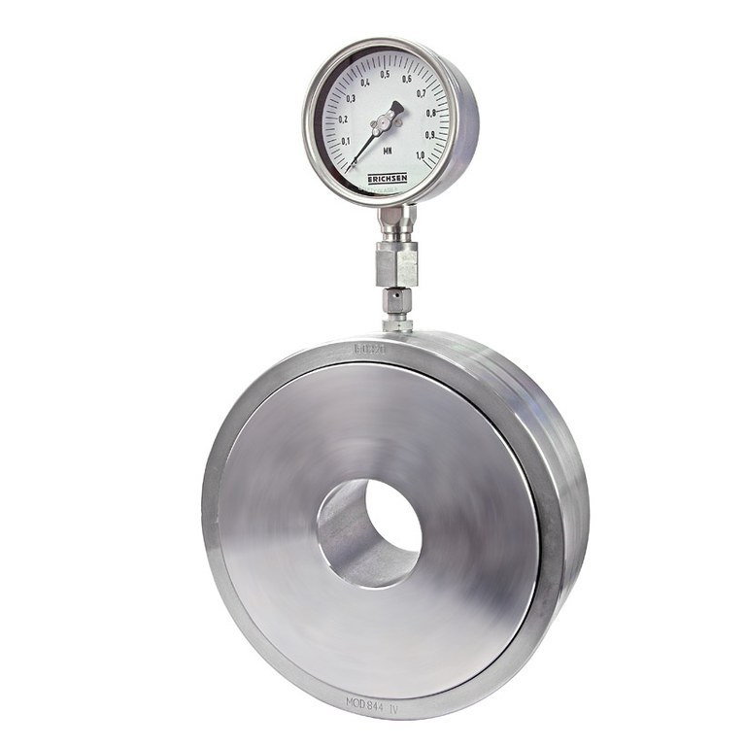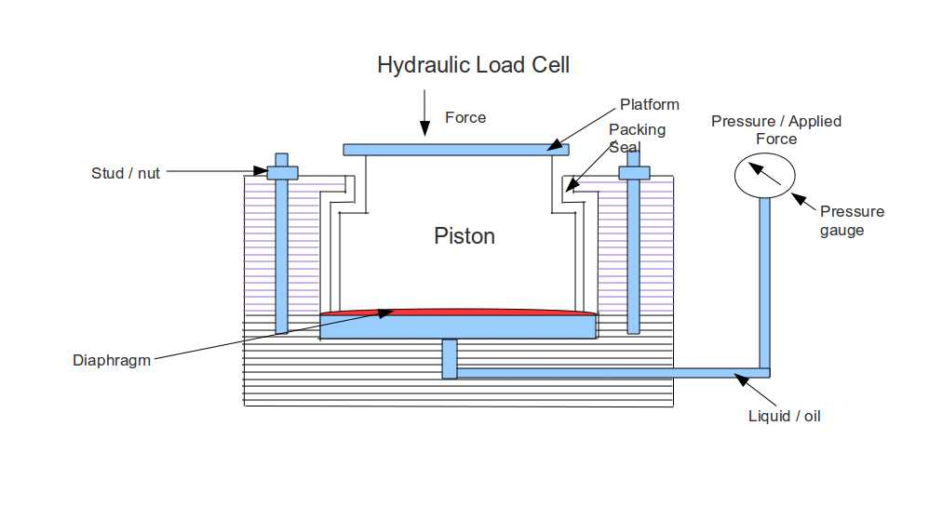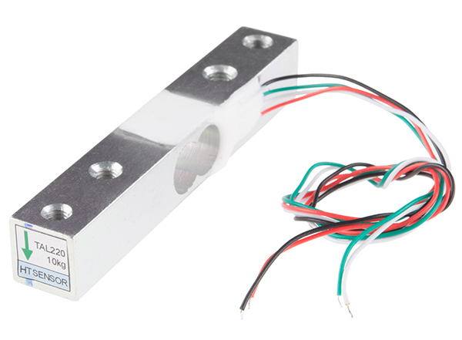

***Hydraulic load cell Pneumatic load cell Strain Gauge load cell***

# **Working Principle:**

In our project, we’re utilizing the strain gauge load cell. Strain gauge load cells usually feature four strain gauges in a Wheatstone bridge configuration, which is an electrical circuit that balances two legs of a bridge circuit. The force being measured deforms the strain gauge in this type of load cell, and the deformation is measured as change in electrical signal.

There are several common strain gauge load cell configurations, including shear beam, s-type, and compression. When force is applied to a load cell, it undergoes deformation (stretching or compression). Strain gauges (tiny resistors) bonded to the load cell experience changes in resistance due to this deformation. These resistance changes are converted into an electrical signal that can be measured and standardized.

# **Specifications:**

* Capacity: 5KG,
* Rated output(MV/V): 2.0±0.15
* Input resistance(O): 402±6
* Output resistance(O): 350±3
* Baud rate: (9600~57600) (default 57600).
* Rated Current: ~120mA.

**The wiring system of the load cell:**

* Red: VCC (E+)
* Black: GND (E-)
* White: Output – (A-)
* Green: Output + (A+)

# **HX711 Load Amplifier:**

The HX711 amplifier is a specialized integrated circuit (IC) primarily designed for amplifying small signals from load cells and strain gauges, commonly used in weight measurement applications. It provides high-precision analog-to-digital conversion with low noise and power consumption, making it popular in various industrial, commercial, and DIY projects.

The HX711 typically operates at low supply voltages, often in the range of 2.7V to 5.5V, which makes it compatible with a wide range of microcontrollers and power sources. It incorporates features like offset and gain calibration, allowing for precise adjustment of the measurement system to account for environmental factors and variations in sensor characteristics.

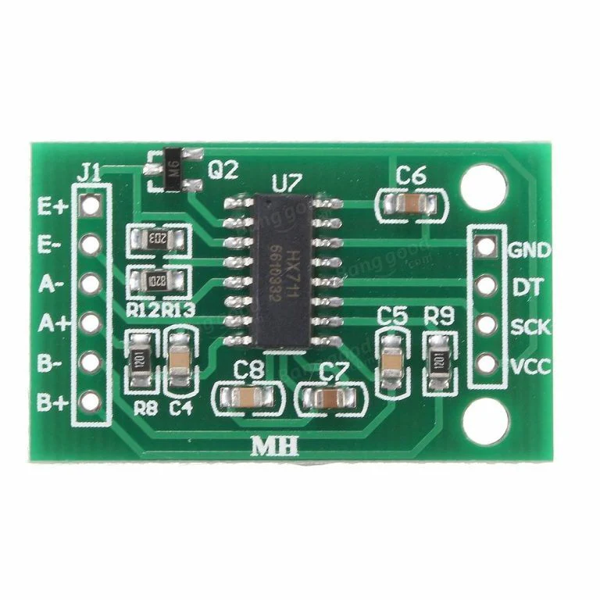

### **Specifications:**

* Differential input voltage: ±40mV(Full-scale differential input voltage is ± 40mV)
* Data accuracy: 24 bit (24 bit A / D converter chip.)
* Refresh frequency: 80 Hz
* Operating Voltage : 5V DC
* Operating current : <10 mA

### **LCD Display:**

Liquid Crystal Displays (LCDs) are widely used in electronic devices for displaying information in a visually readable format. They are characterized by their flat, thin profile and low power consumption, making them suitable for a diverse range of applications.

LCD displays consist of a liquid crystal layer sandwiched between two layers of glass or plastic substrates. The liquid crystal molecules can be manipulated to control the passage of light through the display. Each pixel on the screen corresponds to a segment of the liquid crystal layer, and by selectively activating these pixels, images and text can be displayed.

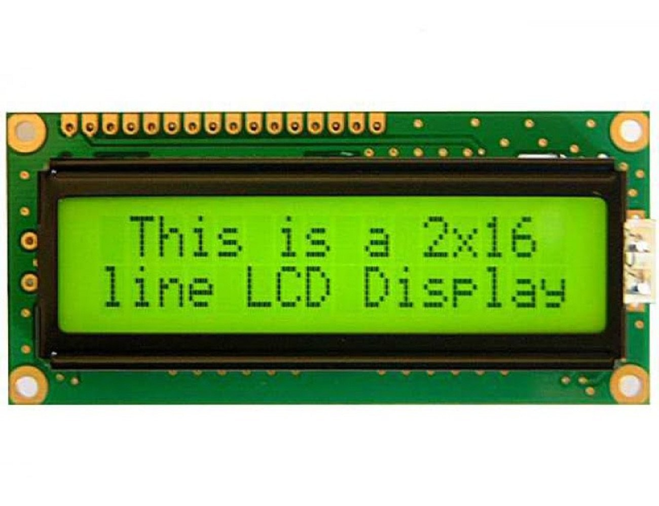

**Working Principle:**

LCDs operate on the principle of light modulation. When an electric field is applied to the liquid crystal molecules, their orientation changes, altering the polarization of light passing through them. By controlling the electric field across different regions of the display, varying levels of light transmission can be achieved, resulting in the display of different colors and shades.

### **Specifications:**

* Operating Voltage: 4.7V to 5.3V
* Operating Current 1mA (without backlight)
* Can display (16x2) 32 Alphanumeric Characters
* Custom Characters Support
* Works in both 8-bit and 4-bit Mode

**I2C Module:**

The Inter-Integrated Circuit (I2C) module is a widely used serial communication protocol designed for efficient data transfer between integrated circuits (ICs) or peripheral devices. It is commonly employed in embedded systems, microcontrollers, and various electronic devices due to its simplicity, versatility, and robustness.

I2C is a synchronous, multi-master, multi-slave serial communication protocol developed by Philips Semiconductor (now NXP Semiconductors). It allows multiple devices to communicate with each other using only two wires - a serial data line (SDA) and a serial clock line (SCL).

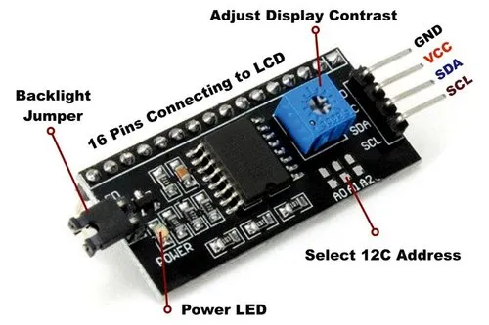

### 

### **Specifications:**

* 5V power supply.
* Serial I2C control of LCD display using PCF8574.
* Backlight can be enabled or disabled via a jumper on the board.
* Contrast control via a potentiometer.
* Size ：41.6 x 19.2 mm.

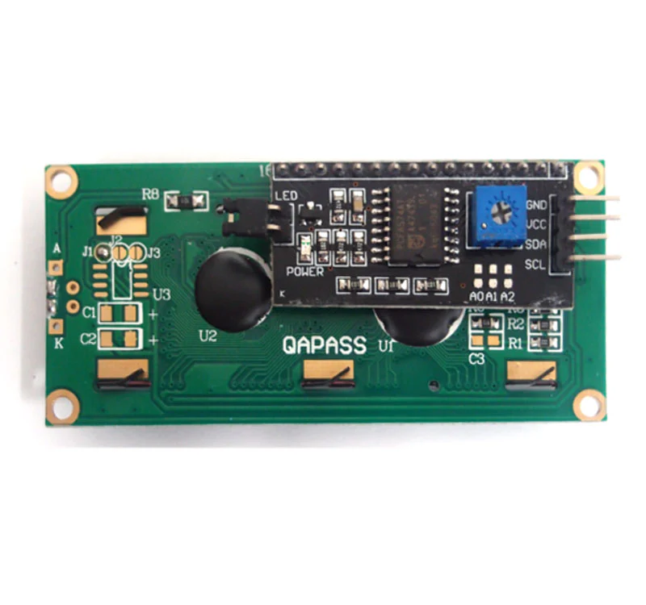

***I2C Module attached to the backside of LCD Display***

### 

### **Buzzer:**

A buzzer is a device that produces an audible signal, or buzz, through the transmission of electrical signals. Buzzers are often used as alarm devices, timers, and to confirm user input. They are like an electric bell, but without the hammer or gong. Buzzers can be mechanical, electromechanical, or piezoelectric.

The pin configuration of the buzzer is shown below. It includes two pins namely positive and negative. The positive terminal of this is represented with the ‘+’ symbol or a longer terminal. This terminal is powered through 6 Volts whereas the negative terminal is represented with the ‘-‘symbol or short terminal, and it is connected to the GND terminal.

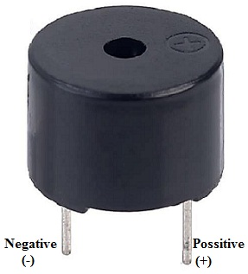

### **Specifications:**

* The frequency: 3,300Hz
* Operating Temperature ranges: – 20° C to +60°C
* Operating voltage: 3V to 24V DC
* Sound pressure level: 85dBA or 10cm
* Supply current <= 15mA

**Block Diagram**

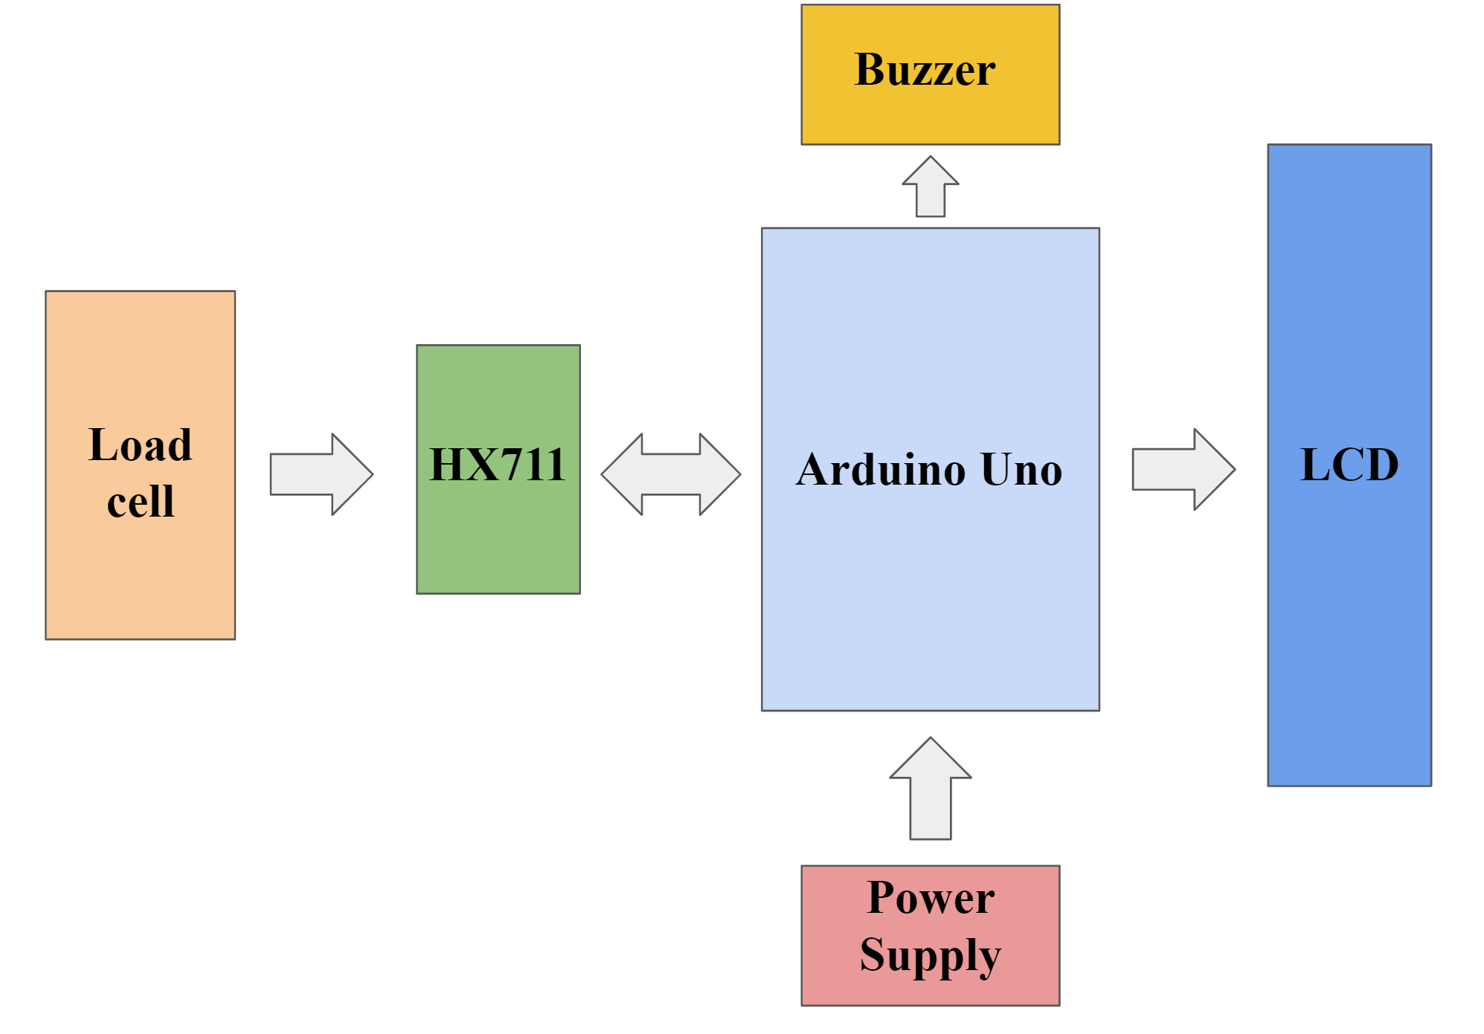

# **Steps to interface Load Cell with Arduino Uno**

### **Step1:**

### Identify the components and make sure all of them are available for interfacing.

### **Required components:**

* Arduino Uno and Arduino IDE software
* Load Cell Sensor
* HX711 Load Cell Amplifier
* LCD Display 16 x 2
* I2C Module
* Buzzer
* Jumper Wires
* Bread Board (Required if we want to connect the display and I2C module separately)

**Step2:**

Give the connections as per the circuit diagrams given below

* **Connections between the load cell, HX711 and Arduino Uno:-**

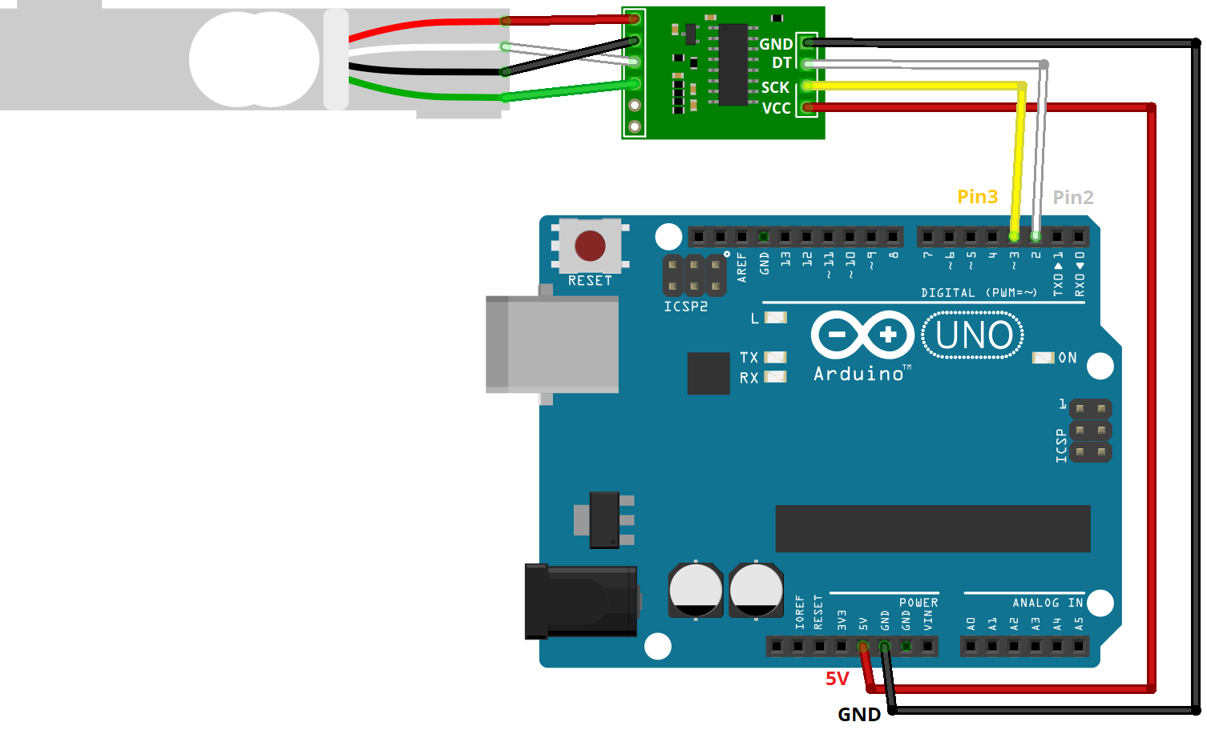

**Here’s a table that summarizes the connections:**

| **Load Cell** | **HX711** | **HX711** | **Arduino** |
| --- | --- | --- | --- |
| **Red (E+)** | **E+** | **GND** | **GND** |
| **Black (E-)** | **E-** | **DT** | **Pin 2** |
| **White (A-)** | **A-** | **SCK** | **Pin 3** |
| **Green (A+)** | **A+** | **VCC** | **5V** |

* **Connections between the LCD Display with I2C module and arduino Uno:**

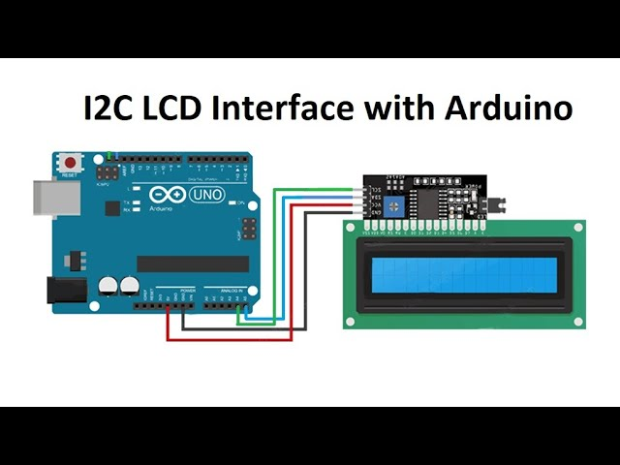

**Step3:**

Make sure all the connections are firm and recheck them once again to avoid loose connections.

**Step4:**

Follow the steps below for the software part: -

1. Open Arduino IDE and go to Tools> Manage Libraries.

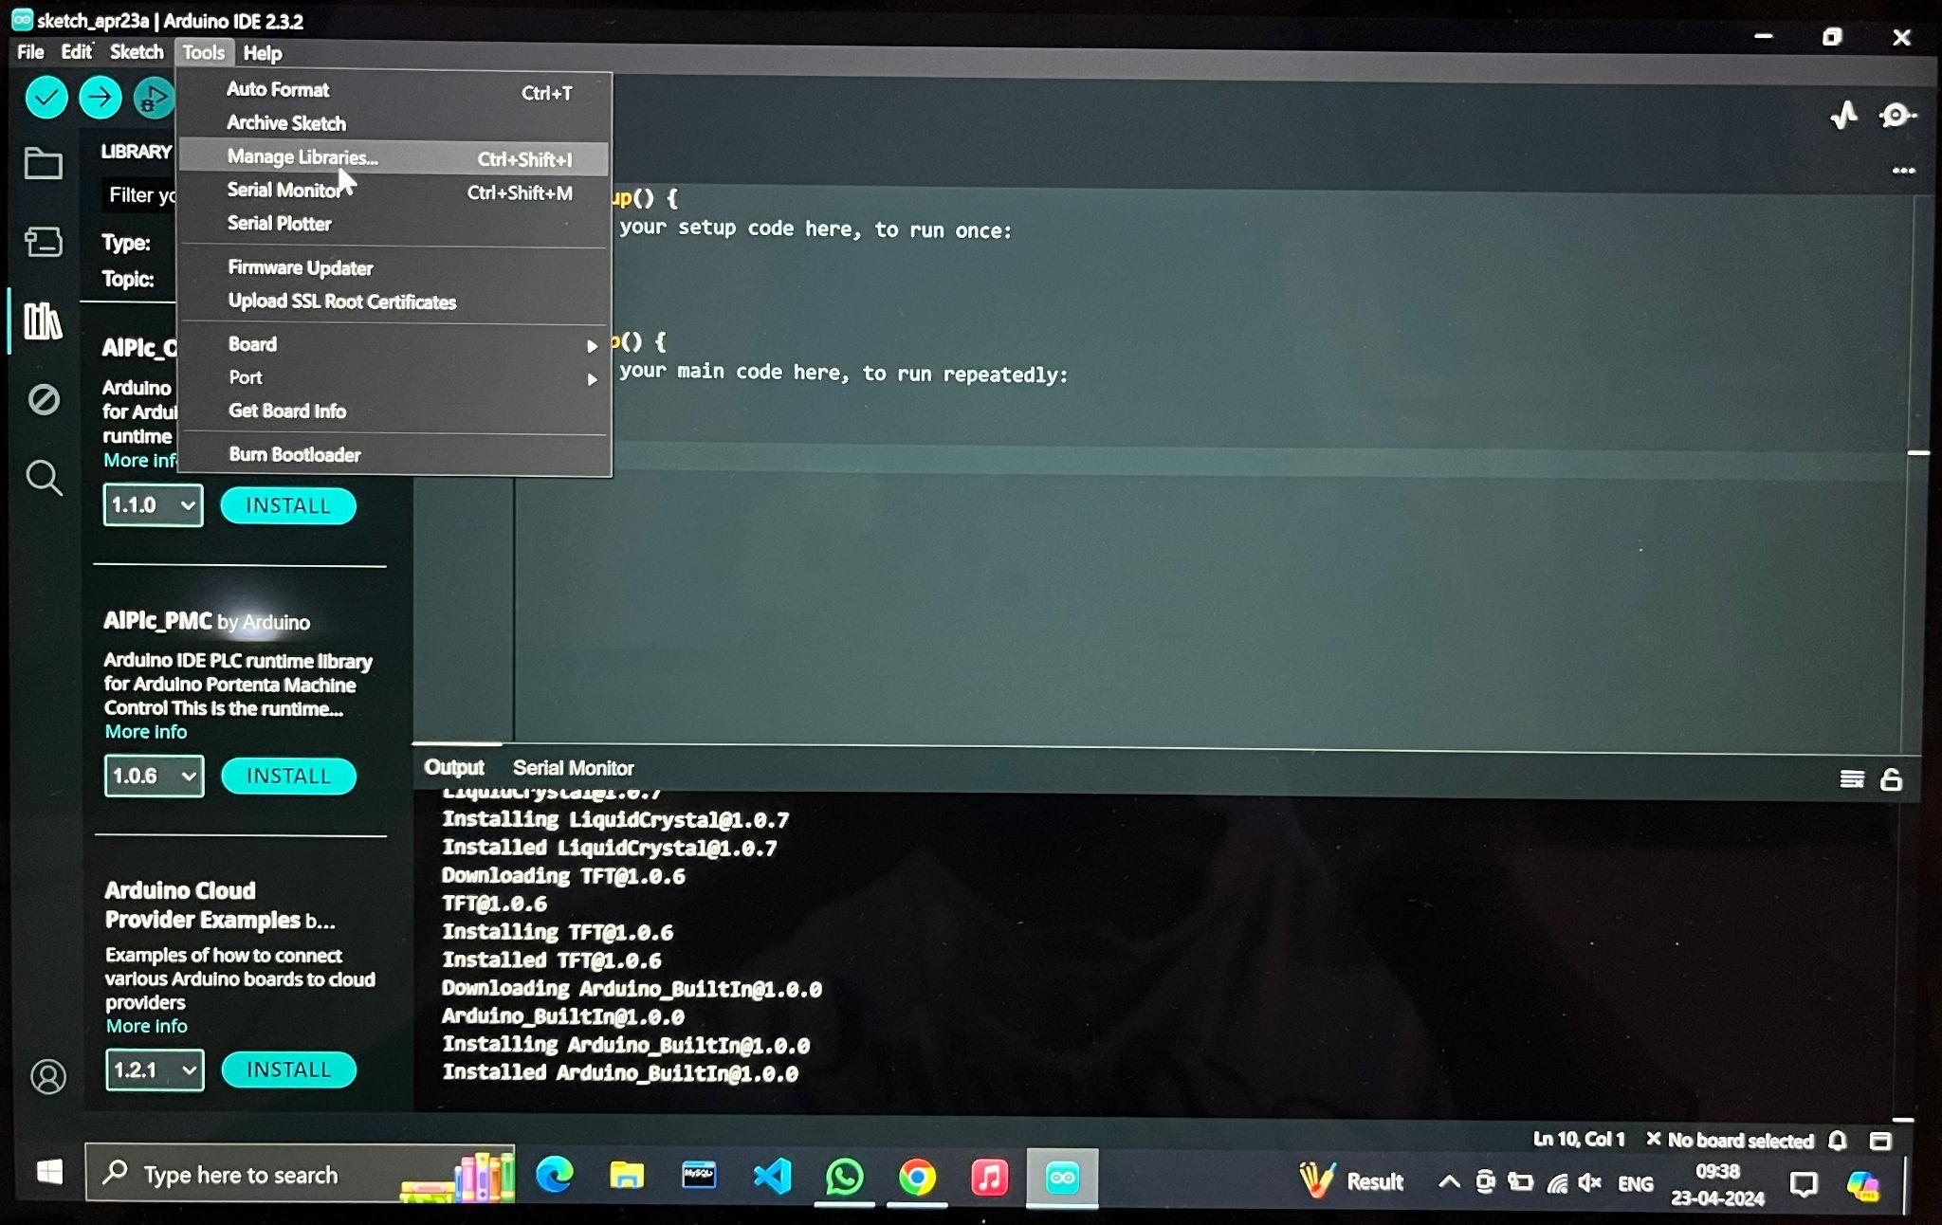

1. Search for “HX711_ADC” and install the library.

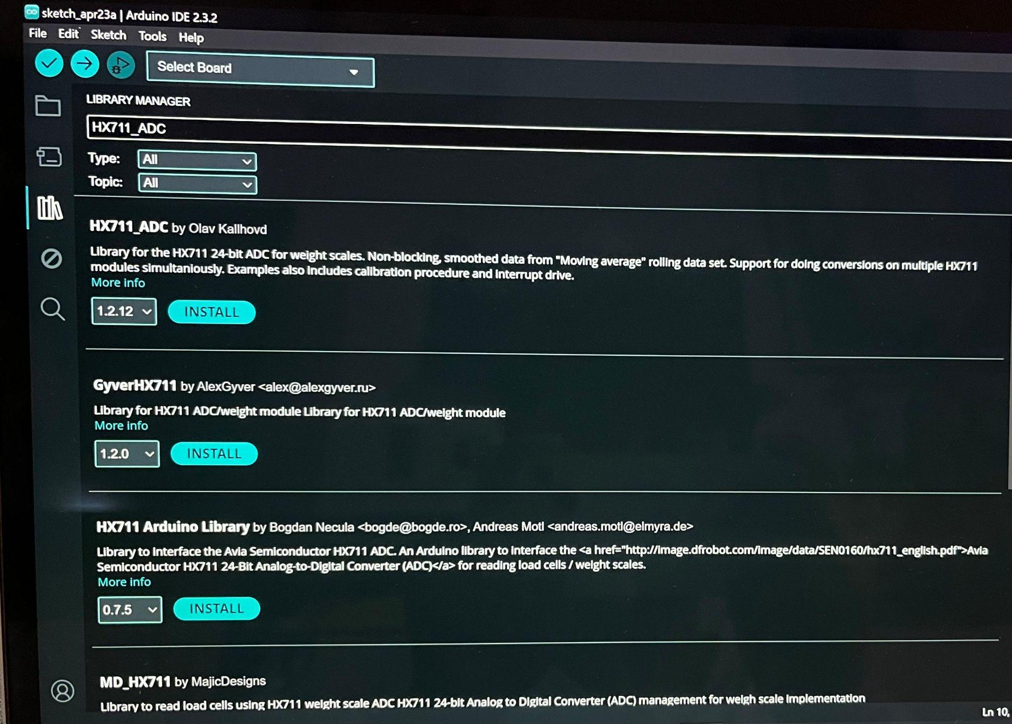

1. After installation, search for “LiquidCrystal” and install the library.

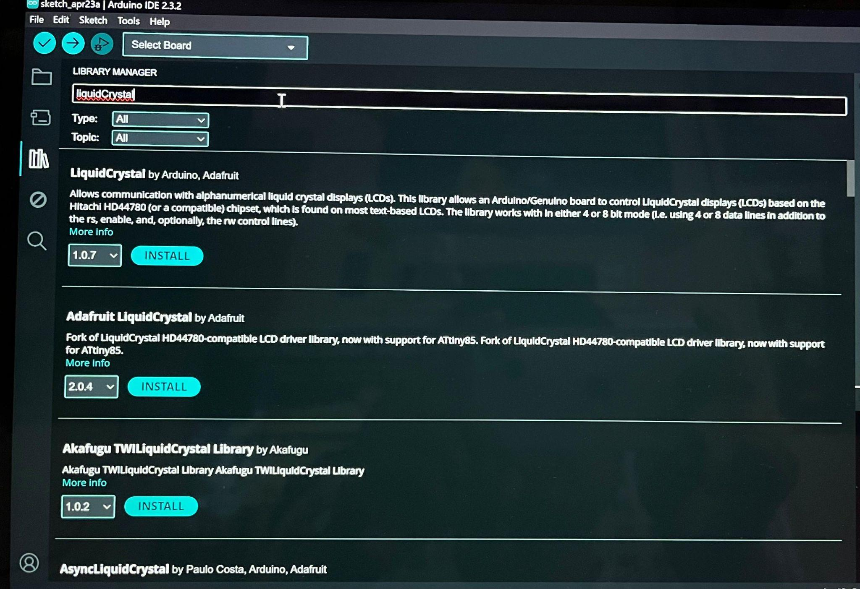

1. Go back to the main window and write the code mentioned below:

**#**include <HX711_ADC.h> **// need to install**

#include <Wire.h>

#include <LiquidCrystal_I2C.h> **// need to install**

HX711_ADC LoadCell(6, 7); **// parameters: dt pin 6, sck pin 7;**

LiquidCrystal_I2C lcd(0x27, 16,2); **// 0x27 is the i2c address might different;you can check with Scanner**

void setup()

{

LoadCell.begin(); **// start connection to HX711**

LoadCell.start(2000); **// load cells gets 2000ms of time to stabilize**

LoadCell.setCalFactor(1000.0); **// calibration factor for load cell => dependent on your individual setup**

lcd.init();

lcd.backlight();

const int buzzerPin = 10;

const int buttonPin = 8;

pinMode(8,OUTPUT**);**

pinMode(buzzerPin, OUTPUT);

bool buzzerState = false;

}

void loop()

{

LoadCell.update(); **// retrieves data from the load cell**

float i = LoadCell.getData(); **// get output value**

lcd.setCursor(0, 0); **// set cursor to first row**

lcd.print("Weight[g]:"); **// print out to LCD**

lcd.setCursor(0, 1); **// set cursor to second row**

lcd.print(i); **// print out the retrieved value to the second row**

if(i>20)

{

digitalWrite(8,HIGH);

digitalWrite(10,HIGH);

buzzerState = true;

} else

{

digitalWrite(8, LOW);

digitalWrite(buzzerPin, LOW);

buzzerState = false;

}

}

Save the file with the name: *XH_711_Load_Cell_Scale.ino*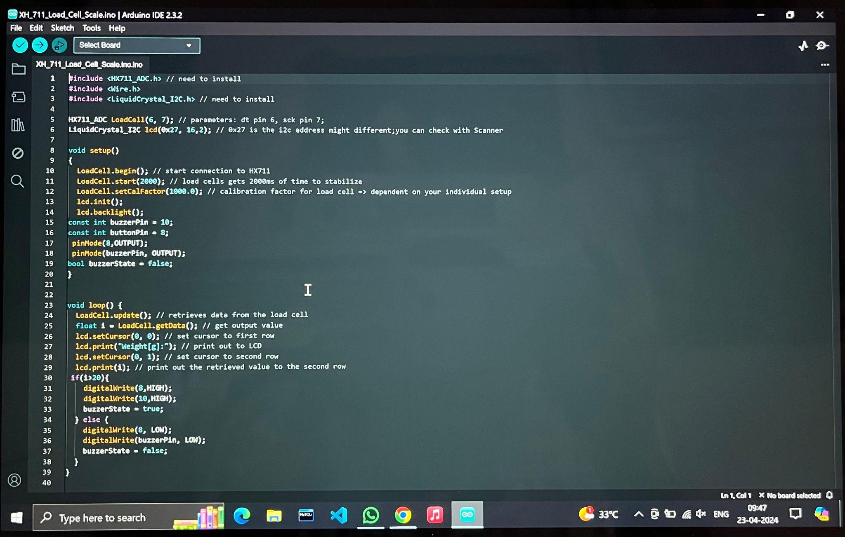

1. Connect the Arduino Uno to the PC through USB.
2. Reset the Arduino Uno.
3. Go to Tools > Board > Select Arduino Uno.

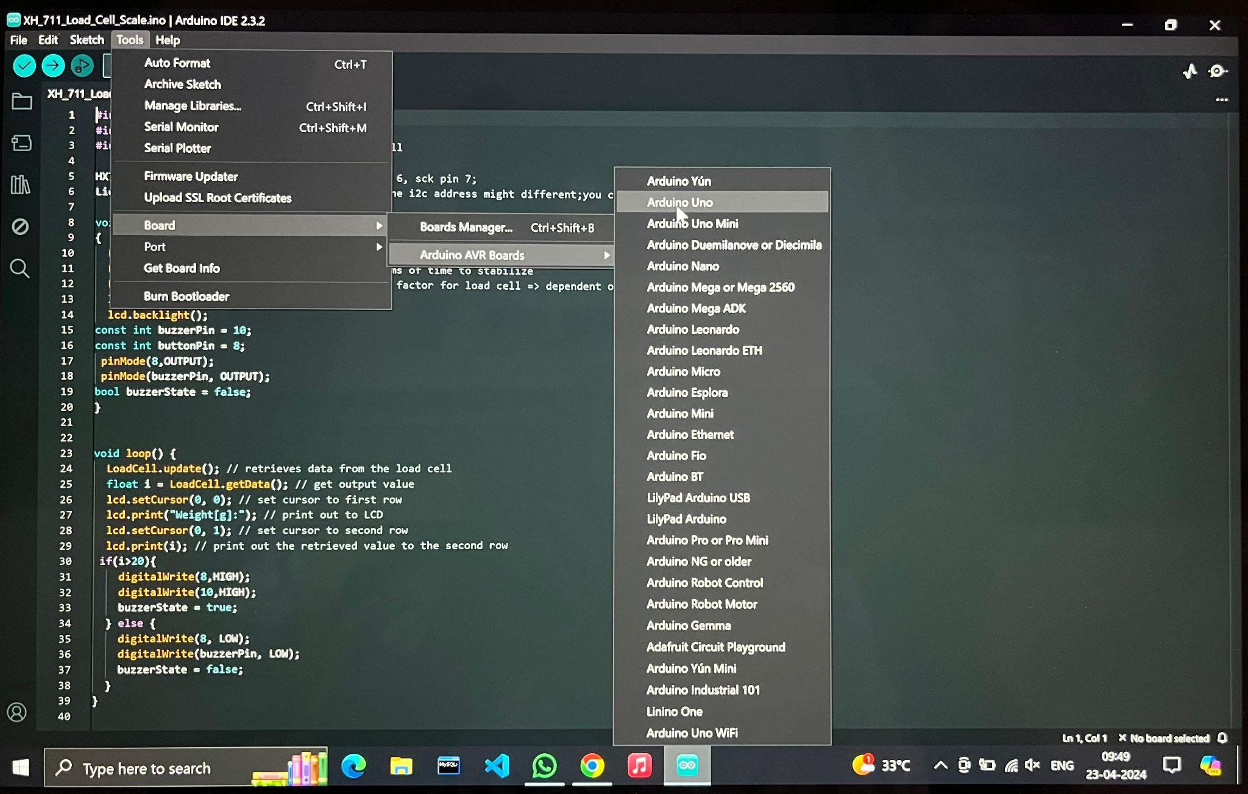

1. Compile and Upload the code.
2. Open the serial monitor window and set the required amount of baud rate.

**Step5:**

Place some weight on top of the load cell.

**Step6:**

The value of the weight placed on the Load Cell is displayed as the output on the LCD display.

**Step7:**

The same output can be observed in the serial monitor window of the Arduino IDE software.

**Step8:**

Increase the weight and observe the buzzer which makes a sound.

**Step9:**

Reduce the weight and observe the buzzer which goes off.

# **References:**

* <https://www.researchgate.net/publication/358895925_Automatic_Load_Detector_Design_to_Determine_the_Strength_of_Pedestrian_Bridges_Using_Load_Cell_Sensor_Based_on_Arduino>
* <https://media.neliti.com/media/publications/411937-an-automatic-load-detector-design-to-det-6ea978f7.pdf>
* <https://ijsrst.com/paper/2443.pdf>
* <https://papers.ssrn.com/sol3/papers.cfm?abstract_id=3918720>